Session | 2024-25 (ODD) |  | Course Name | Web Technology Lab
Semester | 3 |  | Course Code | 23CT1301
Roll No | 43 |  | Name of Student | Chetan M Bobde
Practical Number |  | 8
Course Outcome |  | - Understand various internet technologies.  - Design the web pages using HTML and CSS.  - Implement the XML technology to store the data.  - Develop the interactive web pages using JavaScript.
Aim |  | Aim: Write JavaScript to validate the following fields of the admission Registration page.
Problem Definition |  | The program aims to validate user input on an admission registration page using JavaScript.  It checks whether the entered data in fields like Name, Age, Email, and Phone Number is correct and meets the required conditions.This ensures that the form captures accurate and complete data before submission, preventing errors and invalid entries.
Theory  (100 words) |  | JavaScript form validation is an essential part of web development used to ensure that user inputs are accurate and complete before submitting a form. It helps check whether the required fields contain valid data and follow proper formats. In an admission registration page, fields such as name, email, mobile number, address, date of birth, and course selection must be validated to avoid incorrect entries. JavaScript provides built-in functions and conditional checks to verify input formats, such as checking whether the email contains “@”, the mobile number has the required digits, and no field is left blank. Validation improves data accuracy, prevents errors, enhances user experience, and ensures secure and reliable form submission.  .
Procedure and Execution  (100 Words) |  | Step for Implementation:  1. Create the HTML form with fields like Name, Age, Email, and Phone Number.  2. Write a JavaScript function for validation.  3. Use conditional statements to check each field:  - Name should not be empty.  - Age should be a valid number within range.  - Email should have correct format.  - Phone number should have 10 digits.  4. Optionally, use loops to validate multiple similar fields.  5. Show error messages if any field is invalid.  6. If all validations pass, allow form submission.
Code:
<!DOCTYPE html>
<html>
<head>
<title>Admission Registration Form Validation</title>
<script>
function validateForm() {
let name = document.getElementById("name").value;
let email = document.getElementById("email").value;
let mobile = document.getElementById("mobile").value;
let password = document.getElementById("password").value;
let confirm = document.getElementById("confirm").value;

if (name == "" || email == "" || mobile == "" || password == "" || confirm == "") {
alert("All fields are required!");
return false;
}
let emailPattern = /^[^ ]+@[^ ]+\.[a-z]{2,3}$/;
if (!email.match(emailPattern)) {
alert("Please enter a valid Email ID!");
return false;
}

if (mobile.length != 10 || isNaN(mobile)) {
alert("Please enter a valid 10-digit Mobile Number!");
return false;
}
if (password.length < 6) {
alert("Password must be at least 6 characters long!");
return false;
}

if (password != confirm) {
alert("Passwords do not match!");
return false;
}
alert("Registration Successful!");
return true;
}
</script>

</head>
<body>
<h2>Admission Registration Form</h2>
<form onsubmit="return validateForm()">
<label>Full Name:</label><br>
<input type="text" id="name"><br><br>

<label>Email:</label><br>
<input type="text" id="email"><br><br>

<label>Mobile Number:</label><br>
<input type="text" id="mobile"><br><br>

<label>Password:</label><br>
<input type="password" id="password"><br><br>

<label>Confirm Password:</label><br>
<input type="password" id="confirm"><br><br>

<input type="submit" value="Register">
</form>
</body>
</html>

Output:
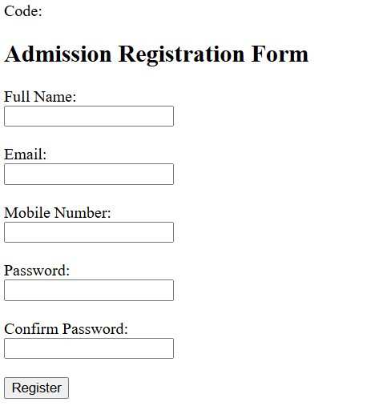
Output Analysis |  | The program displays error messages for invalid inputs and prevents form submission until all fields are correctly filled.  This ensures only valid and accurate data is submitted, demonstrating the correct use of functions, conditions, and loops in JavaScript for form validation.
Link of student Github profile where lab assignment has been uploaded |  | chetanbob999/Web-technology-
Conclusion |  | In this practical, we learned how JavaScript can be used to validate various fields of an Admission Registration form before submitting the data to the server. By applying validation rules to inputs such as name, email, mobile number, and date of birth, we can ensure that the user enters correct and complete information. JavaScript validation helps in reducing errors, preventing invalid entries, and improving the quality of data collected through the form. This experiment also highlighted the importance of enhancing user experience and maintaining data accuracy in web applications through effective client-side validation.
Plag Report (Similarity index < 12%) |  | 9%
Date |  | 27/10/2025

